University of Science and Technology
- Wrocław-



LABORATORY 5: UTILIZING SOFTWARE FOR INTERFACE MODELING

SUPPORT FOR IT PROJECT MANAGEMENT
2025/2026
Teacher: Piotr Zabawa
Student: Álvaro Puebla Ruisánchez 293867

Table of Contents
Table of Contents 2
1. Software Overview 3
1.1 Name and Purpose 3
1.2 Key Functionality 3
1.3 Why Figma Was Selected 4
2. Performed Tasks 5
2.1 Task 1 - Create a Login Page 5
2.2 Task 2 - Create at Least 2 Screens with Tab Menu 6
2.3 Task 3 - Interconnect Screens to Make Navigation 7
3. Summary 8
3.1 Software Suitability Assessment 8
3.2 Evaluation of Software Functionality 8
3.3 User Interface Evaluation 8
3.4 Evaluation of Other Software Attributes 9

1. Software Overview

1.1 Name and Purpose
The software selected for this laboratory session is Figma, a cloud-based interface design and prototyping tool developed by Figma, Inc. Figma is widely adopted in both professional and academic contexts for the creation of user interface mockups, interactive prototypes, and collaborative design workflows. Its primary purpose is to enable designers, developers, and project stakeholders to conceptualise, model, and iterate on application interfaces before any development begins.
In the context of IT Project Management, interface modelling tools such as Figma play a critical role during the requirements elicitation and validation phase. By constructing visual prototypes, project teams can communicate interface requirements to stakeholders with clarity, gather early feedback, and identify potential usability issues before committing resources to implementation.

1.2 Key Functionality
Based on the lecture materials and the practical exercise carried out during the session, Figma provides the following core functionalities:
- Frame Creation: Users can define frames corresponding to specific device form factors (e.g., iPhone, Android Compact), which serve as the canvas for each application screen.
- Component Insertion and Editing: UI elements such as text fields, buttons, images, and icons can be dragged onto frames from the Assets panel and customised via the Design panel.
- Prototyping and Interaction Links: Figma's Prototype mode allows designers to connect UI elements across frames using interaction arrows, simulating navigation flows such as button taps leading to new screens.
- Simulation / Preview Mode: A built-in presentation mode renders the prototype in a realistic device frame, enabling stakeholders to experience interaction flows without any coding.
- Sharing and Collaboration: Designs can be shared via a link, allowing team members to view or comment in real time, supporting iterative design review.
- Property Customisation: Selected elements expose a rich property panel where colours, typography, dimensions, padding, and alignment can be precisely controlled.

1.3 Why Figma Was Selected
As established in the lecture, Figma was selected over alternative tools - Adobe XD, Sketch, and Balsamiq - for two principal reasons: (1) it is available free of charge with no time-based restrictions on its core functionality, and (2) it operates entirely as a web application, requiring no local installation. This makes it immediately accessible on any operating system and well-suited to academic settings where licensing and installation constraints frequently apply.
A comparative analysis presented in the lecture further supports this choice. Adobe XD requires a paid subscription beyond the trial period, Sketch is limited to macOS, and Balsamiq also operates on a subscription model. Figma's free tier combined with its web-based nature and robust feature set makes it the most practical option for laboratory work.

2. Performed Tasks

2.1 Task 1 - Create a Login Page
Task description: The first task required the creation of a login page containing at minimum a username field, a password field, and a login button. The constraint specified that a pre-built login form component should not be used; all elements were to be placed and styled individually.
A new Figma design file was opened and a phone frame was inserted onto the canvas. The frame was placed inside a Section to organise the workspace. A teal-coloured header bar was added at the top, containing the application name "PINGLIS" as a bold title. A penguin mascot graphic was included as a decorative image element beneath the header. Two input field components with dashed borders were inserted: one labelled "USER:" with placeholder text "Write here your username", and a second labelled "PASSWORD:" with placeholder text "Write here your password". Finally, two rounded buttons were placed at the bottom of the frame: the primary action button labelled "LOG IN" and a secondary button labelled "SIGN UP", both styled using the application's teal colour scheme. A parallel variant of this screen - the Sign Up screen - was also created, sharing the same layout and components but oriented around account registration, demonstrating the reusability of the design structure.
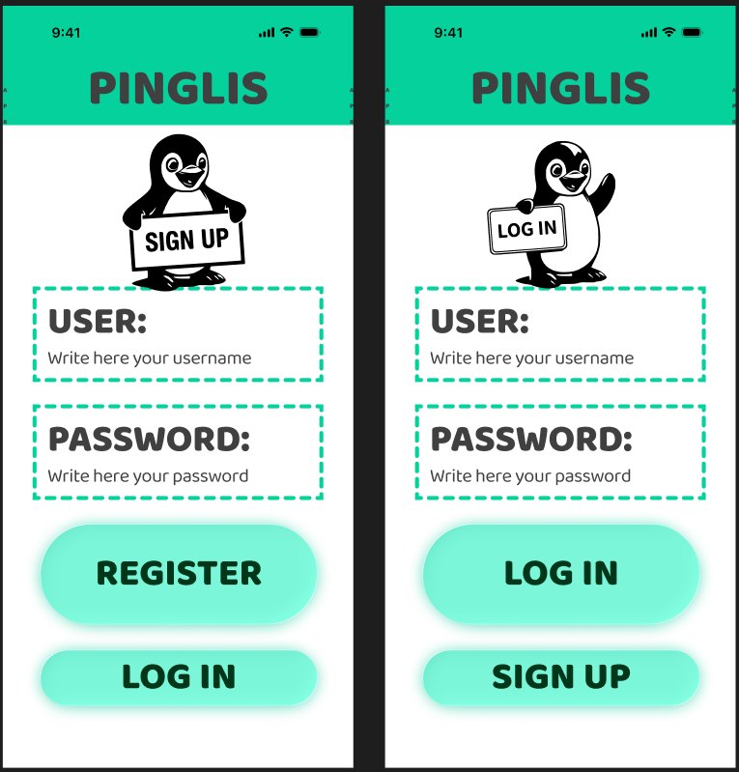
Figure 1. Login and Sign Up screens of the PINGLIS application prototype, showing the username field, password field, and action buttons designed in Figma.

2.2 Task 2 - Create at Least 2 Screens with Tab Menu
Task description: The second task required the creation of at least two distinct application screens, each sharing a common tab menu component to enable navigation between them. Each screen was required to contain different content of at least two elements, while the tab menu area remained consistent across screens.
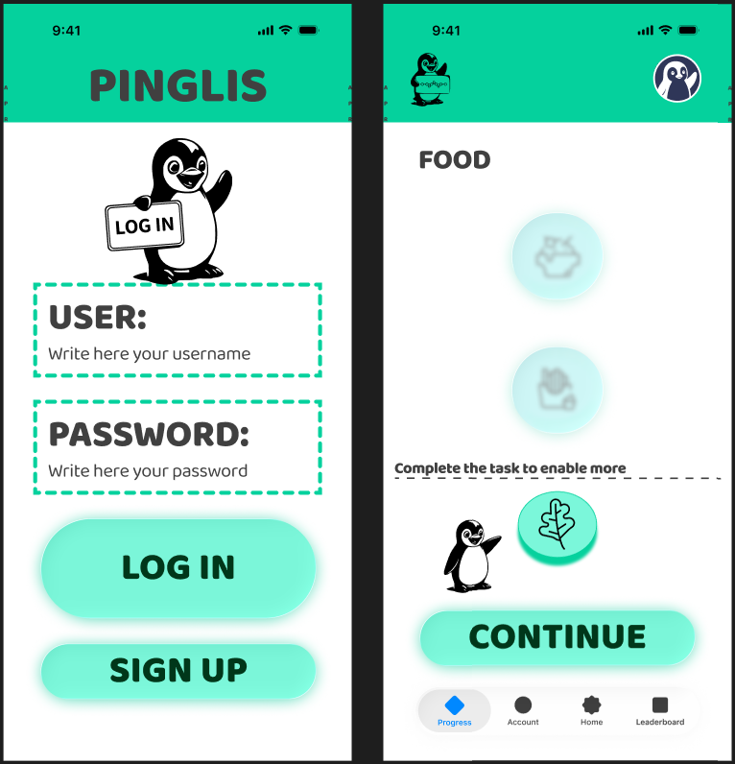
The first screen produced in Task 1 (the Login/Sign Up screen) was retained as the entry point. A second screen was then designed to represent a post-login content view. This screen - titled "FOOD" - featured the same teal header bar with the PINGLIS logo and a user avatar icon in the top right corner. The main content area displayed a category section with circular icon buttons representing different food types, along with a "Complete the task to enable more" prompt and a "CONTINUE" button. At the bottom of this screen, a persistent tab navigation bar was included, consisting of four tabs: Progress (active, highlighted in blue), Account, Home, and Leaderboard. This bottom navigation bar constitutes the tab menu shared between screens and serves as the primary navigation mechanism within the application.
Figure 2. Two-screen layout showing the Login screen and the FOOD content screen with the shared tab menu bar at the bottom, as designed in Figma.

2.3 Task 3 - Interconnect Screens to Make Navigation
Task description: The third task required the connection of the previously created screens using Figma's prototyping tools in order to simulate realistic in-app navigation. Clicking designated interactive elements on one screen should trigger a transition to another.
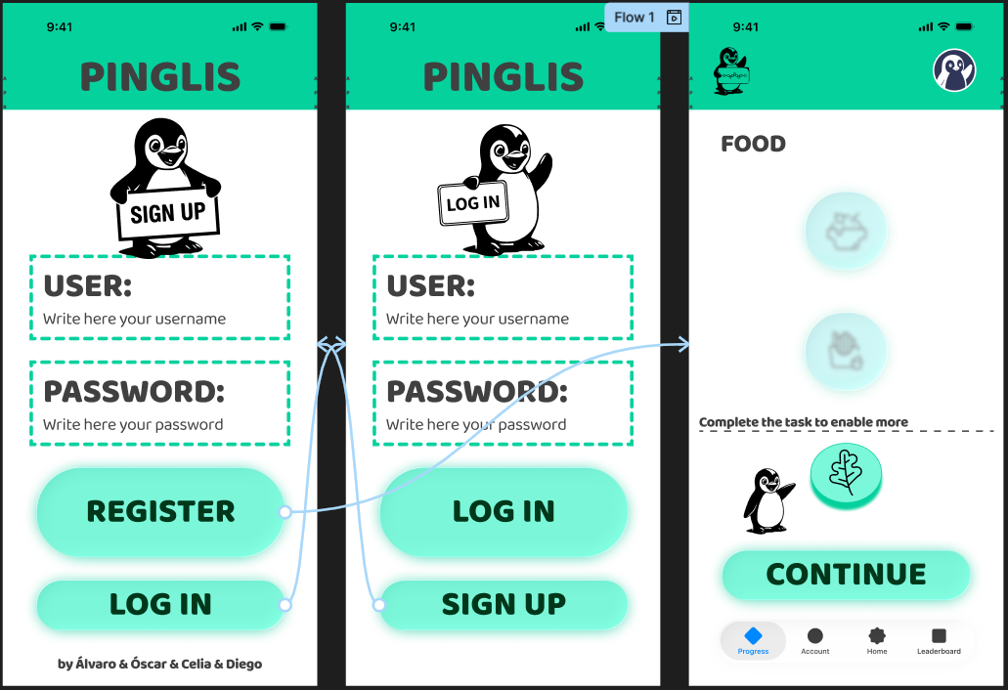
To accomplish this, the editor was switched from Design mode to Prototype mode using the toggle in the top-right panel. In Prototype mode, interactive connections were established by hovering over a UI element until a blue connection handle appeared, then dragging the handle to the target frame. Specifically, the "LOG IN" button on the Sign Up screen was connected to the Login screen, and the "LOG IN" button on the Login screen was connected to the FOOD content screen. The interaction type was set to "On Tap" with a "Navigate To" action, which corresponds to a standard mobile navigation pattern. The resulting flow, labelled "Flow 1" in Figma, was visible as a set of curved arrows spanning across the three frames on the canvas. The prototype was then launched in preview mode, where the interaction chain could be tested end-to-end by tapping through the screens in a simulated device environment.
Figure 3. Prototype view showing all three interconnected screens with navigation flow arrows indicating the transition links established between the Sign Up, Login, and FOOD screens.

3. Summary

3.1 Software Suitability Assessment
Figma proves highly suitable for interface modelling tasks in the context of IT Project Management. It directly supports the creation of screen layouts, interactive prototypes, and navigable flows - all essential artefacts in the requirements and design phases of a project. Its ability to produce both static mockups and dynamic prototypes within a single tool eliminates the need to switch between applications during the design lifecycle. The software aligns well with the MoSCoW-categorised functionality specification presented in the lecture, covering must-have features such as frame creation, component editing, property customisation, and design sharing, as well as should-have features such as prototyping. Figma can therefore be considered a comprehensive and professionally appropriate tool for interface modelling in academic and industry settings alike.

3.2 Evaluation of Software Functionality
Figma's feature set is broad and well-suited to the tasks performed during this session. The frame creation workflow is intuitive, offering a wide selection of preset device sizes that reduces setup time. The Assets panel provides access to a substantial library of design system components, which accelerates the construction of standard UI elements such as buttons and input fields. The Prototype mode is particularly noteworthy: connecting screens via drag-and-drop interaction handles is straightforward, and the resulting flow is immediately testable in preview mode without any export or compilation step. One limitation observed is that the free tier imposes restrictions on the number of design files and advanced features such as branching and version history, which may affect larger team-based projects. Nevertheless, for the scope of laboratory exercises, all required functionalities were accessible without constraint.

3.3 User Interface Evaluation
Figma's own user interface is clean, logically structured, and consistent with modern design tool conventions. The three-panel layout - layers and pages on the left, canvas in the centre, and properties on the right - follows a familiar paradigm that reduces the learning curve for new users. Switching between Design and Prototype modes is seamless, and the canvas supports smooth zooming and panning. The toolbar at the bottom provides quick access to the most commonly used tools such as Frame, Shape, Text, and the connector cursor. One potential challenge for first-time users is the breadth of the properties panel, which exposes a large number of configuration options simultaneously; however, this depth is a strength for more advanced design workflows. Overall, the interface is well-designed and appropriate for users at various experience levels.

3.4 Evaluation of Other Software Attributes
From a performance perspective, Figma operates smoothly as a web application, with no perceptible lag during frame creation, component manipulation, or prototype playback for projects of the scale undertaken in this session. Accessibility is a notable strength: because Figma runs in a browser, it requires no installation and is compatible with Windows, macOS, and Linux environments, making it universally accessible to all students regardless of their hardware configuration. Collaboration features - while not the primary focus of this individual exercise - represent a significant advantage in team-based project settings, as multiple users can edit the same file simultaneously with real-time updates. A relevant limitation is that Figma requires a stable internet connection, as offline editing is not supported in the free tier. Additionally, the tool's focus on visual interface design means it does not natively support requirements documentation or traceability, which are also important aspects of requirements management; it should therefore be used in conjunction with dedicated requirements management tools in a full project workflow.

